Part A:
Request URL: https://www.wikipedia.org/
Request Method: GET
Status Code: 200 OK
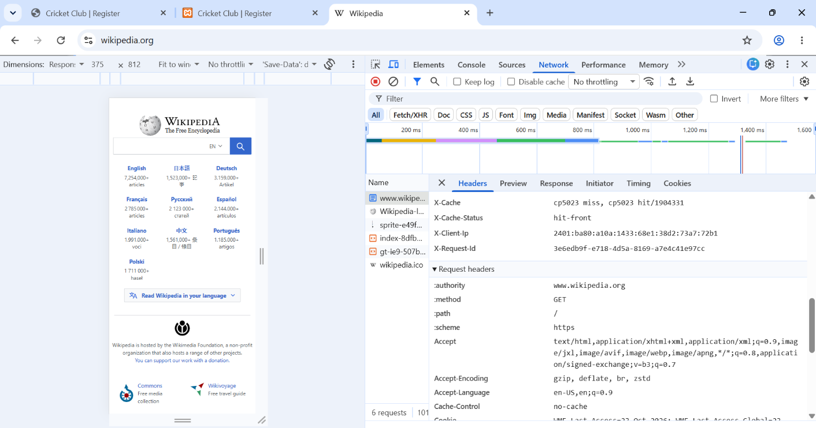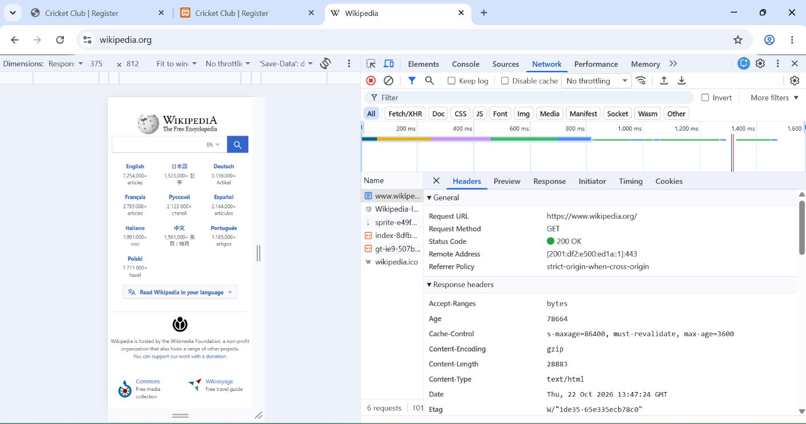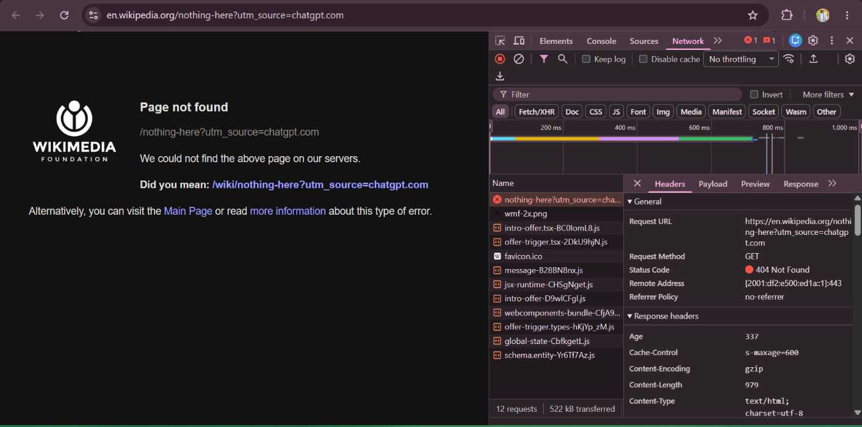

"Request Header Explanation"

accept:
Tells the server which content types the browser can accept.

accept-language:
Tells the server the user's preferred language.

user-agent:
Identifies the browser and device making the request.

"Response Header Explanation"

content-type:
Tells the browser the type of content returned by the server.

content-encoding:
Tells the browser how the response data is compressed.

cache-control:
Gives instructions about caching the response.

Is the website HTTP or HTTPS?

The website uses HTTPS because its URL starts with https://.

What does HTTPS add, and what does the padlock mean?

HTTPS encrypts the data exchanged between the browser and the website. The padlock indicates a secure connection, but it does not guarantee that the website itself is trustworthy.

Website load Diagram

User / Browser
Types https://www.example.com/events
DNS Lookup
Finds the server's IP address
Web Server
Receives the browser's HTTP request
Server Response
Sends HTML and references to CSS and other files
Browser Rendering
Loads required files and displays the webpage
When we type a website address in the browser, the browser first finds the website server with the help of DNS. DNS changes the website name into an IP address. After this, the browser sends a request to the web server to open the page. The server receives the request and sends a response back to the browser. This response contains HTML and information about other files like CSS. HTML gives structure to the webpage and CSS makes it look good. The browser reads the HTML and CSS files and loads other required files like images. After processing all these files, the browser shows the complete webpage on the screen. In this way, a website loads when we enter its address in the browser.

Q1: Difference Between Git and GitHub?
Git is a tool that helps us track changes in our code. GitHub is an online platform where we can upload and share our code with others. Git works on our computer, while GitHub helps us keep our project online.

Q2: What does git add, git commit, and git push do, and in what order are they used?
First, git add selects the files we want to save. Second, git commit saves the changes in our computer with a message. Finally, git push uploads our saved changes to GitHub. The order is git add, git commit, and git push.

Q3: Why is a meaningful commit message better than writing “update” or “final”?
A meaningful commit message tells us what changes we made in the project. It helps us and our team understand the work easily in the future. Messages like “update” or “final” do not clearly explain what was changed.

Part B: